School music development plan 2024/2025
Academic year this summary covers | 2024/2025
Date this summary was published | October 2024
Date this summary will be reviewed | September 2025
Name of the school music lead | Charlotte Horman
Name of school leadership team member with responsibility for music | Mr. Sean Steele and Mrs. Donna Higgens
Name of local music hub | Lancashire Music Hub
Name of other music education partnerships | Kapow and Let’s Go Sing

This is a summary of how Rishton Methodist Primary School delivers music education to all our pupils across three areas – curriculum music, extra-curricular provision and musical experiences – and what changes we are planning in future years.
This information is to help pupils and parents or carers understand what our school offers and who we work with to support our pupils’ music education.
PART A – CURRICULUM MUSIC
Year group | Time dedicated to curriculum music teaching each week
EYFS | Expressive Arts and Design – taught across the week in provision areas, and 1 hour focus time to the subject of music each week.
YEAR 1 | All terms – 1 hour
YEAR 2 | All terms – 1 hour
YEAR 3 | All terms – 1 hour
YEAR 4 | All terms – 1 hour
YEAR 5 | All terms – 1 hour
YEAR 6 | All terms – 1 hour
Curriculum music is music taught in lesson time to ALL pupils.

Curriculum music lessons are informed by the Model Music Curriculum (non-statutory guidance for music teaching) and provide pupils with opportunities to:
- Listen to, appraise and evaluate music from diverse time periods and cultures.
- Learn how to create and control sound using their voices, as well as tuned and un-tuned instruments.
- Understand how music is communicated through various notation systems.
- Improvise and compose music.
- Perform musically in front of audiences of varying sizes.

KEY STAGE 1
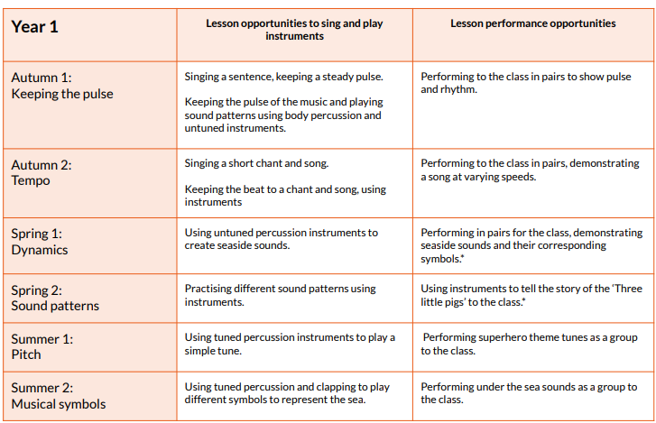

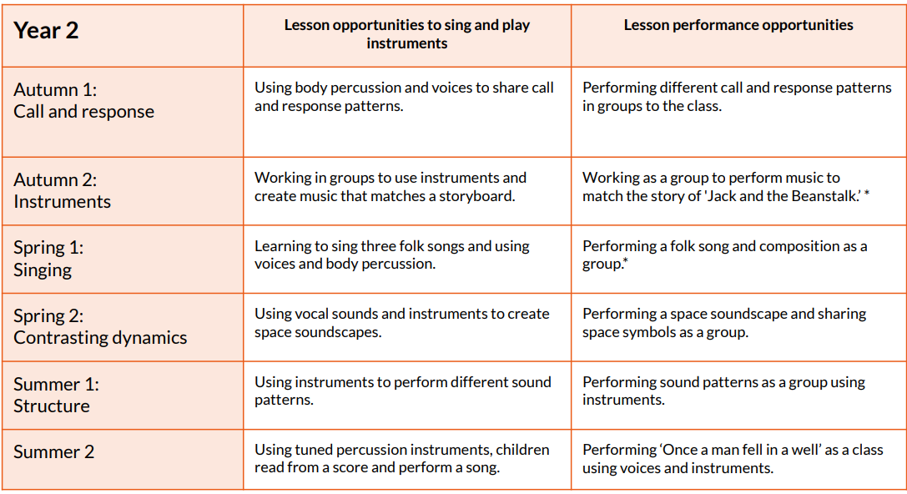

LOWER KEY STAGE 2
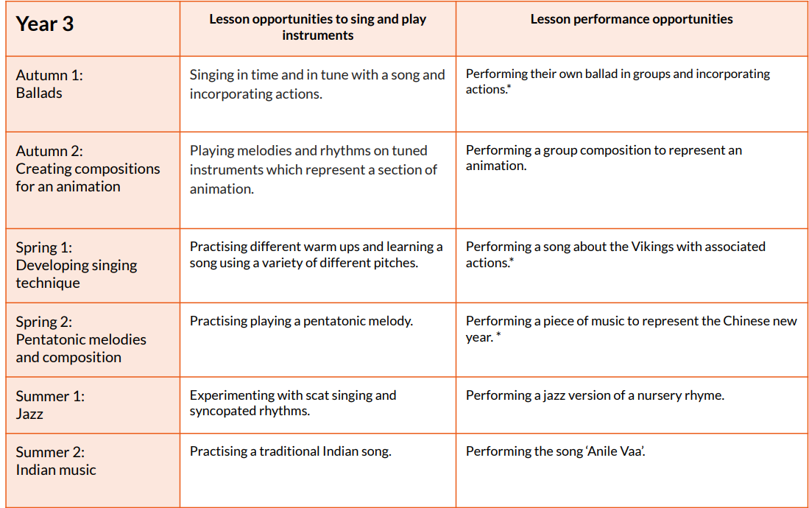
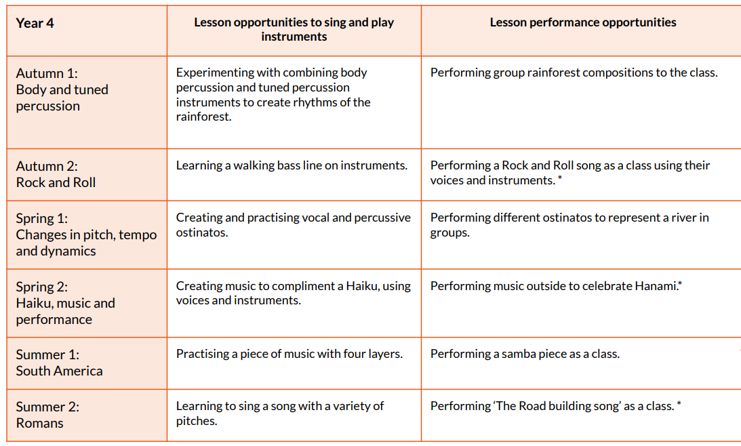

UPPER KEY STAGE 2
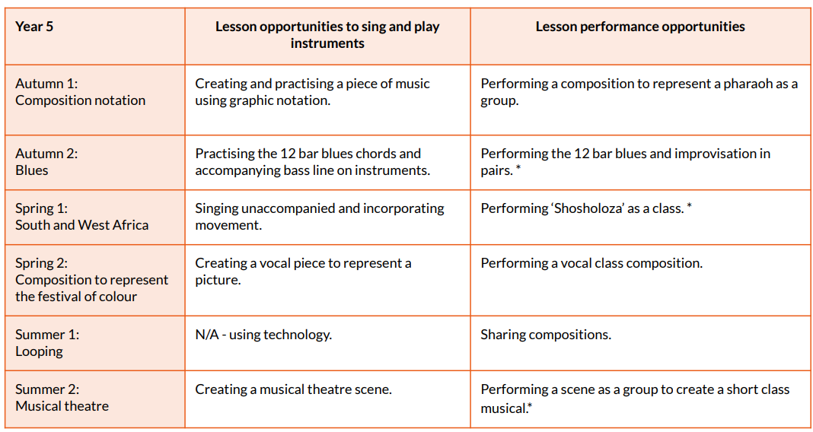

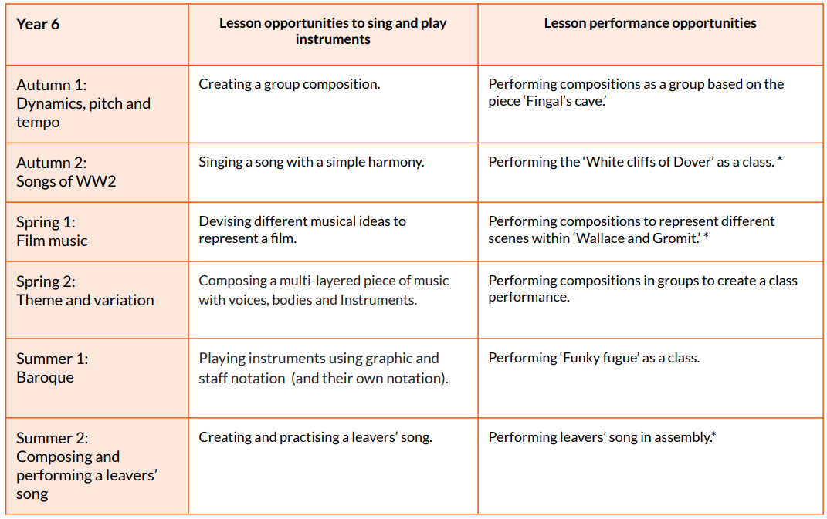

PART B – EXTRA CURRICULUAR MUSIC
Year group | Worship time dedicated to music learning each week | Extra-curricular club opportunities available to all
EYFS | 20 minutes
Year 1 | 20 minutes
Year 2 | 20 minutes
Year 3 | 20 minutes | 1 hour choir each week
Year 4 | 20 minutes | 1 hour choir each week
Year 5 | 20 minutes | 1 hour choir each week  Let’s Go Sing! 2024/2025
Year 6 | 20 minutes | 1 hour choir each week  Let’s Go Sing! 2024/2025

PART C – MUSICAL EXPERIENCES
This section shows all the other musical events and opportunities we organise, such as singing in worships, concerts, shows and trips to professional concerts.

Year group | Autumn | Spring | Summer
EYFS | Pantomime December  Whole Class Worship  Christmas Production | Whole Class Worship | R|ishton’s Got Talent  Whole Class Worship
Year 1 | Pantomime December  Whole Class Worship  Christmas Production | Whole Class Worship | R|ishton’s Got Talent  Whole Class Worship
Year 2 | Pantomime December  Whole Class Worship  Christmas Production | Whole Class Worship | R|ishton’s Got Talent  Whole Class Worship
Year 3 | Pantomime December  Whole Class Worship | Whole Class Worship  Easter Production | R|ishton’s Got Talent  Whole Class Worship
Year 4 | Pantomime December  Whole Class Worship | Whole Class Worship  Easter Production | R|ishton’s Got Talent  Whole Class Worship
Year 5 | Pantomime December  Whole Class Worship  Let’s Go Sing! | Whole Class Worship | R|ishton’s Got Talent  Whole Class Worship  Summer Production
Year 6 | Pantomime December  Whole Class Worship  Let’s Go Sing! | Whole Class Worship | R|ishton’s Got Talent  Whole Class Worship  Summer Production

IN THE FUTURE
Rishton Methodist Primary School is committed to continually enhancing its musical offerings to pupils. Below are the improvements we plan to implement in the coming years. We welcome your suggestions and encourage you to contact the school if you have ideas on how we can further improve our musical opportunities.

Improvement | Who will benefit? | Is the change to:  A – curriculum music  B – extra curricular music  C – musical experiences | When will the change be introduced?
Recorder class tuition to be reintroduced | Children will get the opportunity to play in a recorder ensemble in KS1/KS2? | B | TBC
Dedicated time for individual music lessons to be introduced for KS2 pupils | KS2 pupils will get the opportunity to learn a musical instrument and a 1:1 basis each week. | A/B | TBC
More opportunities for children to experience professional concerts | All children will benefit from experiencing a greater number of professional performances. | C | Ongoing
Termly workshops for children to experience different instruments and music. | All children will benefit on a timetabled basis once per half term, taking part in a musical workshop. | B | TBC
Extra-curricular club opportunities introduced for KS1 pupils. | KS1 pupils will have the opportunity to benefit from extra-curricular music activities. | B | TBC

